 | 12.1.47 Editors - Geometry Nodes Editor - Header - Add Menu - Utilities - Bundle
Table of content
Detailed table of content 1
Add menu - Bundle 2
Combine Bundle 2
Separate Bundle 2
Join Bundle 3

Detailed table of content
Detailed table of content
Detailed table of content 1
Add menu - Bundle 2
Combine Bundle 2
Inputs 2
Sockets 2
Outputs 2
Bundle Socket 2
Separate Bundle 2
Inputs 3
Bundle 3
Outputs 3
Sockets 3
Join Bundle 3
Inputs 3
Bundle 3
Outputs 3
Bundle Socket 3

Add menu - Bundle

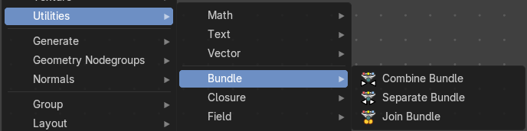
Bundles are like packed containers—they let you group multiple values (like vectors, floats, booleans) into a single wire. Think of them as a way to package data together and pass it around cleanly.

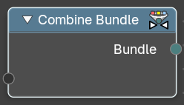
Combine Bundle
This node takes multiple inputs and wraps them into a single bundle.

Inputs

Sockets
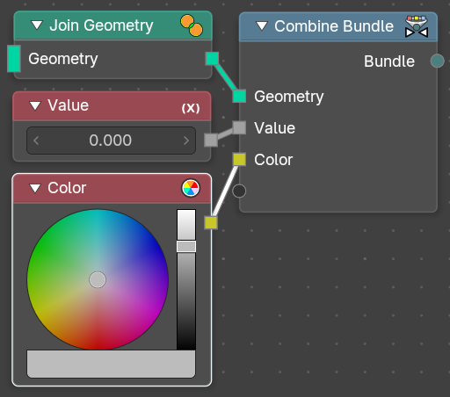
This is a dynamic socket that will populate with whatever you want to plug into it for later use. Accepts one or more bundle-compatible data streams.
These could represent attributes, geometry sets, vales, vectors, or grouped attributes depending on context.

Outputs

Bundle Socket
Standard bundle socket with a unified bundle containing all input elements. Use this to pass the packaged sockets to a Separate Bundle node for later user down the node tree lines.

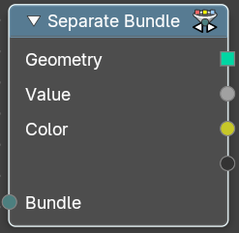
Separate Bundle
This node unpacks a bundle back into its individual components.
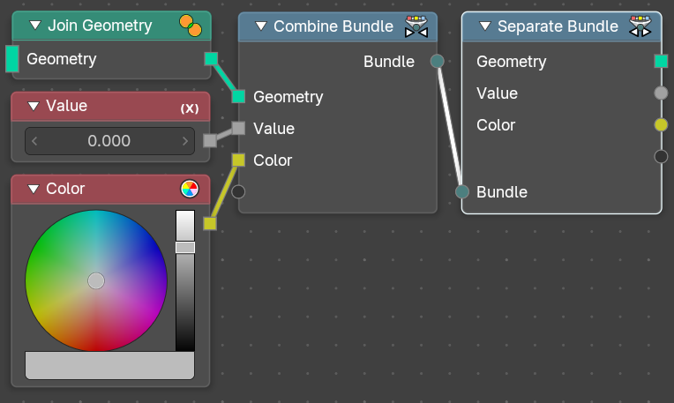

Inputs
The inputs of the node are dynamic. Some inputs are only available in certain operations. For instance, the Scale input is only available in the Scale operator.

Bundle
Standard bundle socket with a unified bundle containing all input elements from a Combine Bundle node.

Outputs

Sockets
This is a dynamic series of socket that will populate with whatever is available from the incoming bundle line. Ouptuts one or more bundle-compatible data streams.
These could represent attributes, geometry sets, vales, vectors, or grouped attributes depending on context.


Join Bundle
Merges two or more Bundle inputs into a single output bundle.
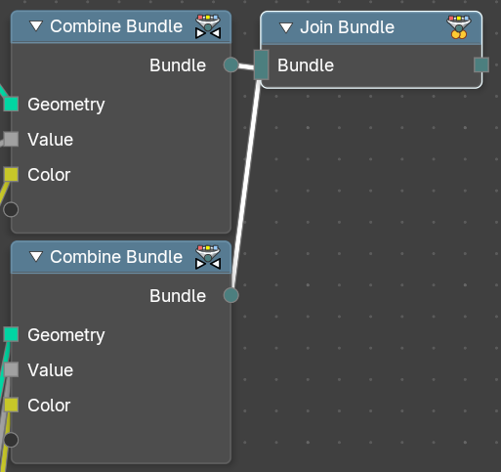
This enables modular data structuring, reuse, and override logic in procedural workflows—similar to combining structs in programming.

Inputs

Bundle
Bundle 1, Bundle 2, … Accepts multiple bundles created via the Combine Bundle node.
Each bundle may contain different types of data (e.g. Float, Vector, String, Color)

Outputs

Bundle Socket
Standard bundle socket with a unified bundle containing all input elements. Use this to pass the packaged sockets to a Separate Bundle node for later user down the node tree lines.

